# Exam 2013, Lecture Project Management

Please write your name on each page.

Name: _____________________________________

Matrikel: ____________________________

Fachbereich: ________________________________

e-Mail: ________________________________

Topic of your Group Work: ________________________________

Hints:

* German text is permitted.
* Simple calculator is permitted.  
  Dictionary (book) is permitted.
* No computers. No other books.
* Rather write less.

Good luck!

## Credits

|  |  |  |  |  |  |  |
| --- | --- | --- | --- | --- | --- | --- |
| 1 | 2 | 3 | 4 | 5 | 6 | Sum |
|  |  |  |  |  |  |  |
| 80 | 36 | 17 | 10 | 12 | 50 | 205 |

## Version History

|  |  |  |  |  |
| --- | --- | --- | --- | --- |
| Version | Status | Date | Comment | Responsible |
| 1.0 | Finished | 24.02.2013 | Initial Version | Malte Foegen |
|  |  |  |  |  |
|  |  |  |  |  |

1. Multiple Choice (78 credits)

**Tick ONE answer per question.**  
Every right answer gives 2 credits; every wrong answer deducts 2 credits.

1. What is Scrum NOT?

* A framework for developing and sustaining complex products
* A project management framework
* A team process
* A set of best practices to evaluate the maturity of project management

1. What is the result of Sprint Planning?

* A Sprint Backlog and an Impediment Backlog
* An estimated Product Backlog and a Sprint Goal
* A Sprint Goal, a forecast of the Product Backlog items delivered in the next Sprint, and a plan how to deliver the Sprint Goal (Sprint Backlog)
* A Sprint Burndown Chart, a Sprint Goal and a Sprint Backlog

1. How long is the Daily Scrum?

* As long as it takes
* 15 min
* 30 min
* 5 min

1. A stakeholder approaches the development team and wants new functionality to be added. It is very important that the feature is added. What should the development team do?

* Discuss the item and add it to the Sprint
* Discuss the item, add it to the Sprint and remove an item of similar complexity
* Discuss the item and add it to the Product Backlog
* Redirect the stakeholder to the Product Owner and get back to work

1. Who determines if the Development Team has achieved the Sprint Goal?

* ScrumMaster
* Product Owner
* Development Team
* Management

1. In Scrum, how do we call the pieces of work that transform a Product Backlog item into a potentially shippable product increment?

* Velocity
* Use Cases
* User Stories
* Tasks

1. Which of the following is NOT a typical artifact in a Scrum project?

* Product Backlog
* Sprint Backlog
* Definition of Done
* Gantt Chart

1. Which statement is accurate about the role of the Product Owner during the Daily Scrum?

* The Product Owner’s participation is defined by the Scrum Team.
* The Product Owner outlines the additional changes that must be absorbed by the Team in the Sprint.
* The Product Owner ensures the Burndown rate is maintained at the estimated rate.
* The Product Owner provides instruction to the Team on how to implement a workable solution.

1. What are the roles in a Scrum project?

* Project Manager, Development Team, Product Owner
* Scrum Master, Development Team, Product Owner
* Scrum Master, Development Team, Product Owner, Line Manager
* Project Manager, Scrum Master, Development Team, Product Owner

1. A Scrum coordination Meeting happens every day at the same time and place. Is that true or false?

* The Development Team decides how often it does the coordination meeting (e.g. every day or every week).
* The Scrum Master decides how often it does the coordination meeting (e.g. every day or every week).
* No. There is no need for a daily meeting.
* Yes. The team does a Daily Scrum every day. That’s why it is called Daily Scrum.

1. Which of the following is NOT a responsibility of the Scrum Master during the Sprint?

* Assign tasks to team members.
* Remove impediments.
* Facilitate in case of conflicts.
* Ensure that the Scrum Team follows the Scrum process and intervene if not.

1. Which of the following is NOT a responsibility of the Product Owner?

* Inspect the increment in the Sprint Review
* Prioritize the items in the Product Backlog
* Add, remove, and break down the Product Backlog items
* Estimate the Product Backlog Items

1. What is the main purpose of a Sprint Review?

* For Stakeholders to "hold the Scrum Team's feet to the fire" - to make sure something is produced during the Sprint
* For the Development Team to review their work and to determine what is needed to complete the next set of backlog items
* For Stakeholders to review what the Scrum Team has built and to give input on what to do next
* For the Product Manager to be able to show progress to the Stakeholders

1. What is the definition of „project“?

* A project involves a unique team that creates a quality product
* A project is a temporary endeavor undertaken to create a unique product or service
* A project is a repeatable endeavor undertaken to deliver a good service
* A project is a temporary endeavor undertaken to create a repeatable product.

1. What is CMMI?

* CMMI is a systematic collection of best practices
* CMMI is a checklist for quality assurance to assess the quality of a team
* CMMI is a project management method
* CMMI is a certification framework and assessment technique

1. What is the structure of CMMI?

* CMMI has several process areas with specific goals and practices. Some process areas also have generic goals and generic practices.
* CMMI has several best practices. Each best practice has a set of specific practices.
* CMMI has several categories that contain process areas. Each process area has a purpose, specific goals and specific practices. Generic Goals and generic practices apply to all process areas.
* CMMI has several categories that contain methods. Each method has best practices.

1. What is a Maturity Level?

* A maturity level is an assessment technique.
* A maturity level describes the skill level of a project manager
* Five maturity levels are used to describe the quality of the software a company produces
* The maturity levels define an improvement path, and they are recognized hallmarks

1. What are the Maturity Levels?

* Initial, Unmanaged, Managed, Quantitatively Managed, Perfectly Managed
* Initial, Managed, Defined, Quantitatively Managed, Optimizing
* Undefined, Managed, Defined, Quantitatively Managed, Repeating
* Initial, Managed, Defined, Quantitatively Managed, Seriously Managed

1. What is a capability level?

* A capability level contains generic management practices that describe the activities needed to establish and maintain a way of work (institutionalize a way of work)
* A capability level describes the skill level of a project manager
* A capability level is a certification level of a project manager
* A capability level is an award given by the quality department to a project team

1. How are CMMI and agile methods related?

* CMMI is a waterfall method and Scrum is an agile method. Both are incompatible.
* CMMI is for certification purposes and has no relation to agile methods.
* CMMI is for certification only and does not help an agile team
* Agile methods are possible “how-to’s” for CMMI practices

How does Scrum implement the CMMI practice REQM SP 1.3 “Manage changes to the requirements as they evolve during the project?”

* Changes to the requirements are allowed at any time. The Product Owner accepts or rejects them and puts them into the Product Backlog. They are discussed in the next Grooming.
* Changes to the requirements require a written change request that is estimated and approved/rejected by the Product Owner.
* Changes to the requirements are allowed at any time. The Development Team estimates and approves/rejects them. If the Team approves them, the project implements the changes immediately.
* Changes to the requirements are not allowed after the stakeholders have signed the Requirements Definition Document.

1. What is NOT an example for requirements?

* User Stories
* Impediments
* Use Cases
* Change request specification

1. What is the purpose of Project Planning (PP)?

* The purpose of ‘Project Planning’ is to establish and maintain plans that define project activities.
* The purpose of ‘Project Planning’ is to write a schedule.
* The purpose of ‘Project Planning’ is to estimate and control the budget.
* The purpose of ‘Project Planning’ is to establish and agree plans with management that define how the project executed so that management can take appropriate actions when the team does not adhere to the plan.

1. How does Scrum implement the CMMI practice PP SP 3.3 ”Obtain commitment from relevant stakeholders responsible for performing and supporting plan execution?”

* The quality assurance department reviews the Increment in the Sprint Review and gives permission to start the next Sprint.
* The Product Owner reviews the Increment in the Sprint Review and gives permission to start the next Sprint.
* The Development orders the Product Backlog items and commits the Product Backlog.
* Development Team and Product Owner commit in Sprint Planning to the Sprint Goal.

1. How does a Scrum Team establish estimates of work Product and task attributes (PP SP 1.2) with the Planning Poker technique?

* Every Product Backlog item is estimated with effort in person days.
* A Scrum team does not estimate.
* Every Product Backlog item is estimated with Story Points. Story Points are relative effort.
* The Development Team estimates the task efforts in person days.

1. What are elements of a project plan according to CMMI?

* Requirements, Budget and Schedule, Project Risks, Project’s Resources, Needed Knowledge and Skills,
* Measurements, Budget and Schedule, Project Risks, Project’s Resources, Stakeholder Involvement
* Budget and Schedule, Project Risks, Data Management, Project’s Resources, Needed Knowledge and Skills, Stakeholder Involvement
* Budget and Schedule, Project Risks, Project’s Resources, Communication Plan, Escalation Plan, Negotiation Plan

1. What is the purpose of Project Monitoring and Control (PMC)?

* The purpose of Project Monitoring and Control is to provide management with an understanding of the project’s progress so that management can take corrective actions.
* The purpose of Project Monitoring and Control is to provide an understanding of the project’s progress so that appropriate corrective actions can be taken when the project’s performance deviates significantly from the plan.
* The purpose of Project Monitoring and Control is to gather data about the progress of the project so that management understands where actions are needed.
* The purpose of Project Monitoring and Control is to analyze the project plan and the budget so that appropriate reports can be written.

1. How does Scrum implement CMMI PMC SP 1.1 “Monitor the actual values of the project planning parameters against the project plan?”

* The Product Owner monitors progress of the product with the Release Burndown.
* The Development Team monitors progress of the Sprint with the Sprint Backlog and the Sprint Burndown.
* The Product Owner monitors progress of the product with the Release Burndown. The Development Team monitors progress of the Sprint with the Sprint Backlog and the Sprint Burndown.
* The Scrum Master monitors the progress of the Sprint with the Sprint Burndown.

1. How does Scrum implement CMMI PMC SP 1.6 “Periodically review the project’s progress, performance, and issues?”

* Sprint Planning
* Sprint Retrospective
* Daily Scrum
* Grooming

1. How does Scrum implement CMMI SP 1.7 “Review the project’s accomplishments and results at selected project milestones?”

* Sprint Planning
* Grooming
* Daily Scrum
* Sprint Review and Sprint Retrospective

1. What is Earned Value?

* Earned value is a technique for forecasting how a project is doing in terms of its budget and schedule.
* Earned value is a technique for forecasting how a project is doing in terms of its commitments.
* Earned value is an alternative name for the Release Burndown Chart.
* Earned value are the tasks completed in a Sprint Burndown chart.

1. What is the purpose of Risk Management (RSKM)?

* The purpose of ‘Risk Management’ is to identify problems and to track them until they have been solved.
* The purpose of ‘Risk Management’ is to identify potential problems before they occur so that risk can be reported to higher level management.
* The purpose of ‘Risk Management’ is to identify potential problems before they occur so that risk handling activities can be planned and invoked as needed to mitigate adverse impacts on achieving objectives.
* The purpose of ‘Risk Management’ is to identify risks so that the extra costs of project can be calculated and budgeted.

1. What are NOT typical risk parameters?

* Risk age (i.e. time since it has been detected)
* Risk likelihood (i.e., probability of risk occurrence)
* Risk consequence (i.e., impact and severity of risk occurrence)
* Thresholds to trigger management activities

1. What is NOT an adequate risk mitigation action?

* Risk privatization: Making risks private to the project to ensure stakeholders stay confident about the project
* Risk control: taking active steps to minimize risks
* Risk monitoring: watching and periodically reevaluating the risk for changes in assigned risk parameters
* Risk acceptance: acknowledging risk but not taking action

1. What is the purpose of Supplier Agreement Management (SAM)?

* The purpose of ‘Supplier Agreement Management’ is to write and manage contracts for the acquisition of products and services from suppliers.
* The purpose of ‘Supplier Agreement Management’ is to put pressure on suppliers to make sure they do their best.
* The purpose of ‘Supplier Agreement Management’ is to manage the acquisition of products and services from suppliers.
* The purpose of ‘Supplier Agreement Management’ is to report conformity of suppliers with appropriate contracts to higher level management.

1. What is NOT a supplier in the sense of CMMI’s Supplier Agreement Management (SAM)?

* Team Members
* In-house suppliers (i.e., suppliers that are in the same organization but are external to the project)
* Suppliers of reuse libraries
* Commercial suppliers (i.e. external vendors).

1. What is the purpose of Measurement and Analysis?

* The purpose of ‘Measurement and Analysis’ is to develop and sustain a measurement capability used to support management information needs.
* The purpose of ‘Measurement and Analysis’ is to develop extensive measurements to ensure management has as much data as possible.
* The purpose of ‘Measurement and Analysis’ is to provide higher level management with key data.
* The purpose of ‘Measurement and Analysis’ is to establish a financial controlling function used to support government information needs.

1. What is NOT a measurement to track the progress of the project?

* Sprint Burndown Chart
* Earned Value Chart
* Milestone Trend Chart
* Gantt Chart

1. What is the purpose of measurements?

* To track the performance of team members
* To report progress to management
* To provide transparency to stakeholders who have an information need
* To establish and maintain a Balanced Scorecard

1. What is the velocity of a Scrum Team?

* The velocity describes how many Story Points the Scrum Team delivers per Person day (SP/PD)
* The velocity describes how many Story Points the Scrum Team estimates it will deliver in the next Sprint
* The velocity describes how many Story Points the forecasted Product Backlog Items have
* The velocity describes the number of days the teams needs until it finishes the release

1. Earned Value (36 credits)
2. Define the Earned Value metrics (12 credits)

|  |  |  |
| --- | --- | --- |
|  | Name | Metric |
| BCWS |  |  |
| ACWP |  |  |
| BCWP |  |  |
| SV |  |  |
| CV |  |  |
| SPI |  |  |
| CPI |  |  |
| CSI |  |  |
| BAC |  |  |
| EAC |  |  |
| PAC |  |  |
| TAC |  |  |

1. Calculate the Earned Value, which the project has on the 25.02.2013 and forecast the budget at completion. (24 credits – only for SV, CV, SPI, CPI, BAC, EAC, PAC, TAC).

|  |  |  |  |  |  |  |  |
| --- | --- | --- | --- | --- | --- | --- | --- |
| Result | Work Planned | Budgeted Cost (PD) | Work Completed | Actual Cost (PD) |  |  |  |
| Requirements specification | 18.01. | 5 | 18.01. | 4 |  |  |  |
| Usability Design | 21.01. | 9 | 25.01. | 10 |  |  |  |
| Wireframes | 25.01. | 5 | 28.01. | 10 |  |  |  |
| System Architecture | 21.01. | 10 | 28.01. | 5 |  |  |  |
| Database Design | 28.01. | 16 | ongoing | 20 |  |  |  |
| Class Diagram | 13.02. | 9 | 13.02. | 8 |  |  |  |
| Web page texts | 15.02. | 4 | 18.02. | 5 |  |  |  |
| Screens | 15.02. | 7 | 22.02. | 3 |  |  |  |
| Backend code | 27.02. | 5 | 22.02. | 7 |  |  |  |
| System Test | 28.02. | 8 |  |  |  |  |  |
| User Validation | 21.03. | 2 |  |  |  |  |  |
| User Acceptance Test | 25.03. | 9 |  |  |  |  |  |
| Lessons Learned | 01.04. | 1 |  |  |  |  |  |
| Sums | ---- |  | ----- |  |  |  |  |
| SV | | | | |  | | |
| CV | | | | |  | | |
| SPI | | | | |  | | |
| CPI | | | | |  | | |
| BAC | | | | |  | | |
| EAC | | | | |  | | |
| PAC | | | | |  | | |
| TAC | | | | |  | | |

1. Project Planning (17 credits)

List the **goals** and **practices** of Project Planning (PP)

1. Measurement and Analysis (10 credits)

List the **goals** and **practices** of Measurement and Analysis (MA).

1. Burndown Chart (12 credits)
2. Look at the Sprint Board. It is day 3 of 13. The team just finished the Daily Scrum at 9 am. At the Daily Scrum on the 2nd day the team had done 2 tasks.  
   Draw the Sprint Burndown Chart with the ideal burndown line, and the two correct data points. (6 credits)  
   If the team continues with this speed, how many tasks will be left at the end of day 13? Draw the appropriate lines in the Burndown graph. (6 credits)

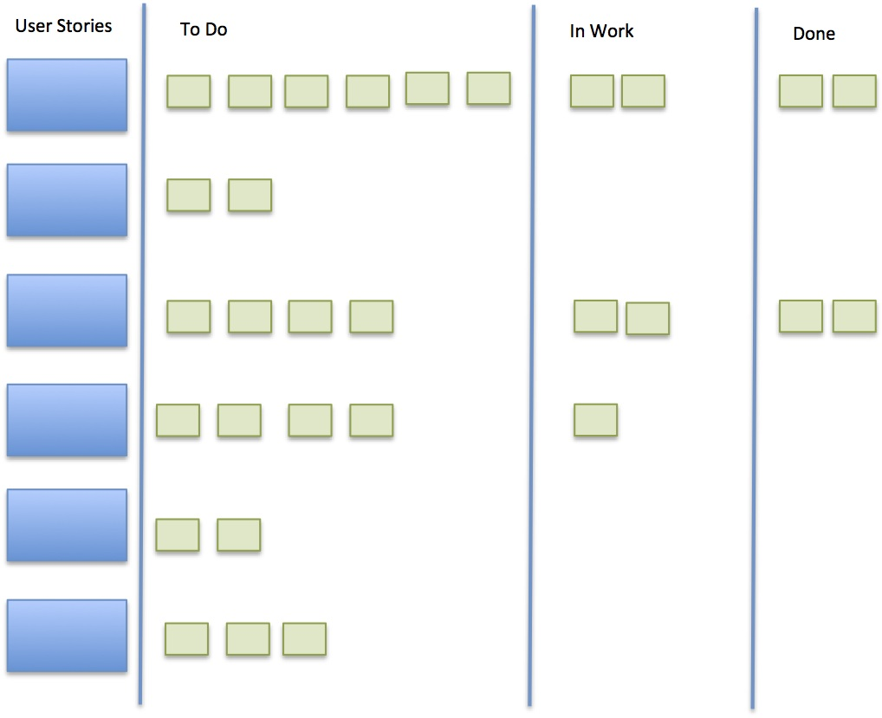

|  |  |  |  |  |  |  |  |  |  |  |  |  |  |  |  |
| --- | --- | --- | --- | --- | --- | --- | --- | --- | --- | --- | --- | --- | --- | --- | --- |
| 30 |  |  |  |  |  |  |  |  |  |  |  |  |  |  |  |
|  |  |  |  |  |  |  |  |  |  |  |  |  |  |  |  |
|  |  |  |  |  |  |  |  |  |  |  |  |  |  |  |  |
|  |  |  |  |  |  |  |  |  |  |  |  |  |  |  |  |
|  |  |  |  |  |  |  |  |  |  |  |  |  |  |  |  |
|  |  |  |  |  |  |  |  |  |  |  |  |  |  |  |  |
|  |  |  |  |  |  |  |  |  |  |  |  |  |  |  |  |
|  |  |  |  |  |  |  |  |  |  |  |  |  |  |  |  |
|  |  |  |  |  |  |  |  |  |  |  |  |  |  |  |  |
|  |  |  |  |  |  |  |  |  |  |  |  |  |  |  |  |
| 20 |  |  |  |  |  |  |  |  |  |  |  |  |  |  |  |
|  |  |  |  |  |  |  |  |  |  |  |  |  |  |  |  |
|  |  |  |  |  |  |  |  |  |  |  |  |  |  |  |  |
|  |  |  |  |  |  |  |  |  |  |  |  |  |  |  |  |
|  |  |  |  |  |  |  |  |  |  |  |  |  |  |  |  |
|  |  |  |  |  |  |  |  |  |  |  |  |  |  |  |  |
|  |  |  |  |  |  |  |  |  |  |  |  |  |  |  |  |
|  |  |  |  |  |  |  |  |  |  |  |  |  |  |  |  |
|  |  |  |  |  |  |  |  |  |  |  |  |  |  |  |  |
|  |  |  |  |  |  |  |  |  |  |  |  |  |  |  |  |
| 10 |  |  |  |  |  |  |  |  |  |  |  |  |  |  |  |
|  |  |  |  |  |  |  |  |  |  |  |  |  |  |  |  |
|  |  |  |  |  |  |  |  |  |  |  |  |  |  |  |  |
|  |  |  |  |  |  |  |  |  |  |  |  |  |  |  |  |
|  |  |  |  |  |  |  |  |  |  |  |  |  |  |  |  |
|  |  |  |  |  |  |  |  |  |  |  |  |  |  |  |  |
|  |  |  |  |  |  |  |  |  |  |  |  |  |  |  |  |
|  |  |  |  |  |  |  |  |  |  |  |  |  |  |  |  |
|  |  |  |  |  |  |  |  |  |  |  |  |  |  |  |  |
|  |  |  |  |  |  |  |  |  |  |  |  |  |  |  |  |
| 0 | 1 | 2 | 3 | 4 | 5 | 6 | 7 | 8 | 9 | 10 | 11 | 12 | 13 | 14 | 15 |

1. Case Study (50 Punkte)

Read the following case study. Identify the problems of the project.

* Mark the text where you identify a problem
* Specify the specific or the generic practice of CMMI where you think the problem is
* Name the problem

**The project WHISS develops a tax system for the government of Hermannie. The project involves 10 people. The project is managed with classic project management techniques.** WHISS has a project manager (Liss) and 10 subteams, each with a team leader. The subteams are organized like small projects in a large project. There is also a project office which provides planning support for the overall project and the subteams.

|  |  |  |
| --- | --- | --- |
| The Case | CMMI Practice | Problem |
| There is a requirements definition document with use cases which states the requirements of the project. Bob, who is the chairman of the requirements board, has signed this document. When requirements board decides on a change, Bob calculates the costs and adds the requirement to the list. Sometimes high profile politicians require changes. Bobs accepts these changes without further discussion. |  |  |
| Bob presents the current list of requirements in a monthly meeting to the team leaders. Together they determine which team implements them. Afterwards the team leaders give the document with the changes to their teams. This seems to work well because the teams ask no questions. |  |  |
| Each team updates the schedule for the subteam every month. The project management office (PMO) integrates the plans each month for the team leader meeting. Because the project schedules are very detailed and the project is rather large, the integration of the plans takes about 3 weeks. Therefore the integrated plan is always 3 weeks behind the actual project.  In the teams the team members work with Tasks boards because the plans are always 3 weeks behind (due to the integration issue). |  |  |
| There are various risks the team members have articulated in the past. Lisa called a risk meeting where the risks have been identified and collected. Lisa did not yet have time to write the risk list and categorize the risks. |  |  |
| There is a reporting system in the project and to the stakeholders. The team leads fill out a report to Lisa, and Lisa writes an overall report to the stakeholders. This report lists the risks discussed in the team leader meeting, and the current budget, and the milestones. |  |  |
| Due to the changes to the requirements 5 of the 10 teams have a “hunch” they are behind schedule. However, team members do not track the effort. Nobody relates the task boards o the teams to the schedule. There is no measurement, either. |  |  |
| There is an external supplier for the database system. This supplier is managed by one of the teams. Because the teams are under pressure, they are glad the external supplier does some of the work. Delivery is scheduled in 6 months. Until then the team is happy that there are few meetings and discussions with the external supplier. This helps the team not to become distracted with problems of the supplier. |  |  |
| The project management office has calculated the earned value of the project. The project is currently 100% over budget and 50% behind time. However, this over-budget and behind-schedule issue appears only in the earned value analysis. After an intensive discussion the team leaders decided that the forecast of the earned value analysis is probably wrong. The report to the stakeholders is therefore “green”. |  |  |
| Until now there is been no project analysis and quality assurance, because reports show the project is well on schedule. |  |  |